**CS7280 – Internet of Things**

Submitted by – Yash Choukse

**Project Vayu**

**Alexa controlled Multifunction remote**

**GitHub Repo**

<https://github.com/yash1195/vayu.git>

**Abstract**

The idea of the project is to control any device that uses IR signals for control from a central hub through Alexa. For this project, a fan was chosen as the target device.

**Introduction**

The fan is able to receive the following instructions from an IR remote:

* Power on/off
* Change fan speed
* Turn fan swing movement on/off

The goal is that a user should be able to initiate these commands through Alexa voice commands. A hub should be responsible for then actually sending these commands to the device through Infrared.

The hub should also be able to receive AlertNode signals and react to them.

This seems like an interesting project because there are a lot of moving parts that need to work in sync for it to work. The project deals with Wifi, radio communication, Infrared communication, communication over MQTT protocol and Alexa (for voice commands).

This project makes an originally non-smart device into a smart device without making physical changes to the device itself.

**Architecture**

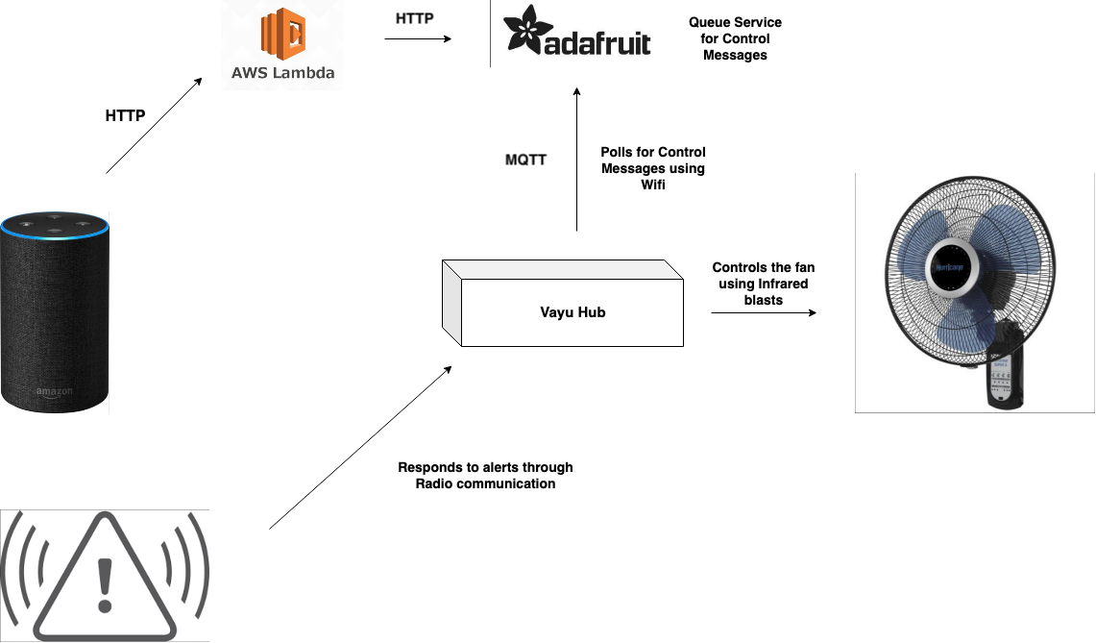

User gives commands to an Alexa device.

This command is processed by a AWS Lambda function. This function generates a control message and sends the message to an Adafruit feed.

The hub consists of two Arduino boards.

**Board 1:** This is the module that talks to the cloud part of the project. It has a Wifi shield and is subscribed to the Adafruit feed. It keeps scanning for a new control message in the feed. Whenever a new control messages is received, it sends a digital signal to Arduino 2.

**Board 2:** This is the module that has an XBee shield and receives radio input. It also takes input from the other Arduino. It also has an IR led attached to it to transmit IR signals whenever it is signaled by the other board to do so.

**Bill of Materials / Components**

Arduino Boards - 2

Wifi Shield (ATWINC1500) - 1

XBee Shield - 1

XBee Radio - 1

IR LED - 1

IR Received - 1   
Battery pack – 1

LEDs - 3

Jumper wires

Breadboard

**Schematic**

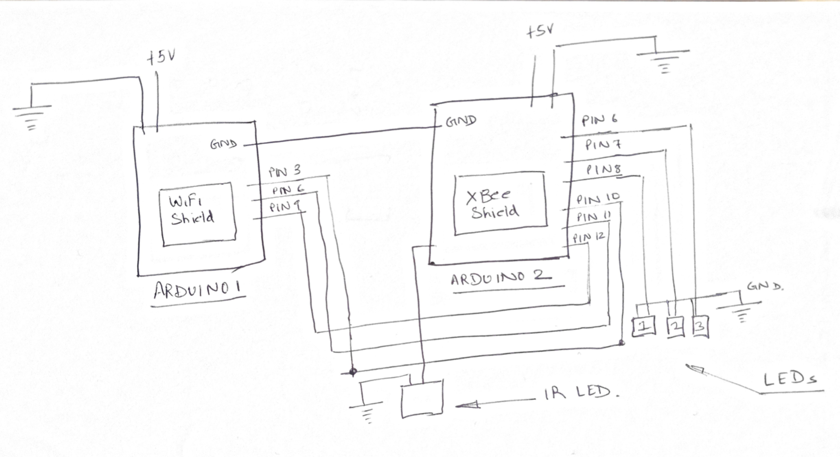

**Photos of the build**

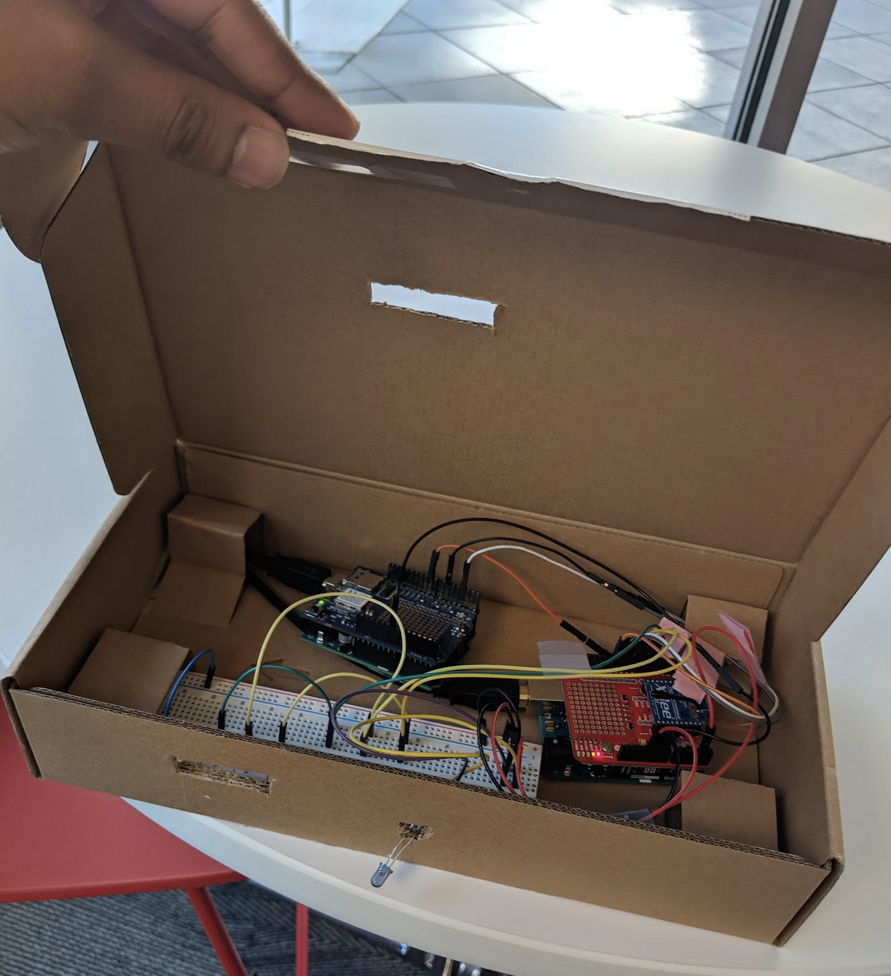

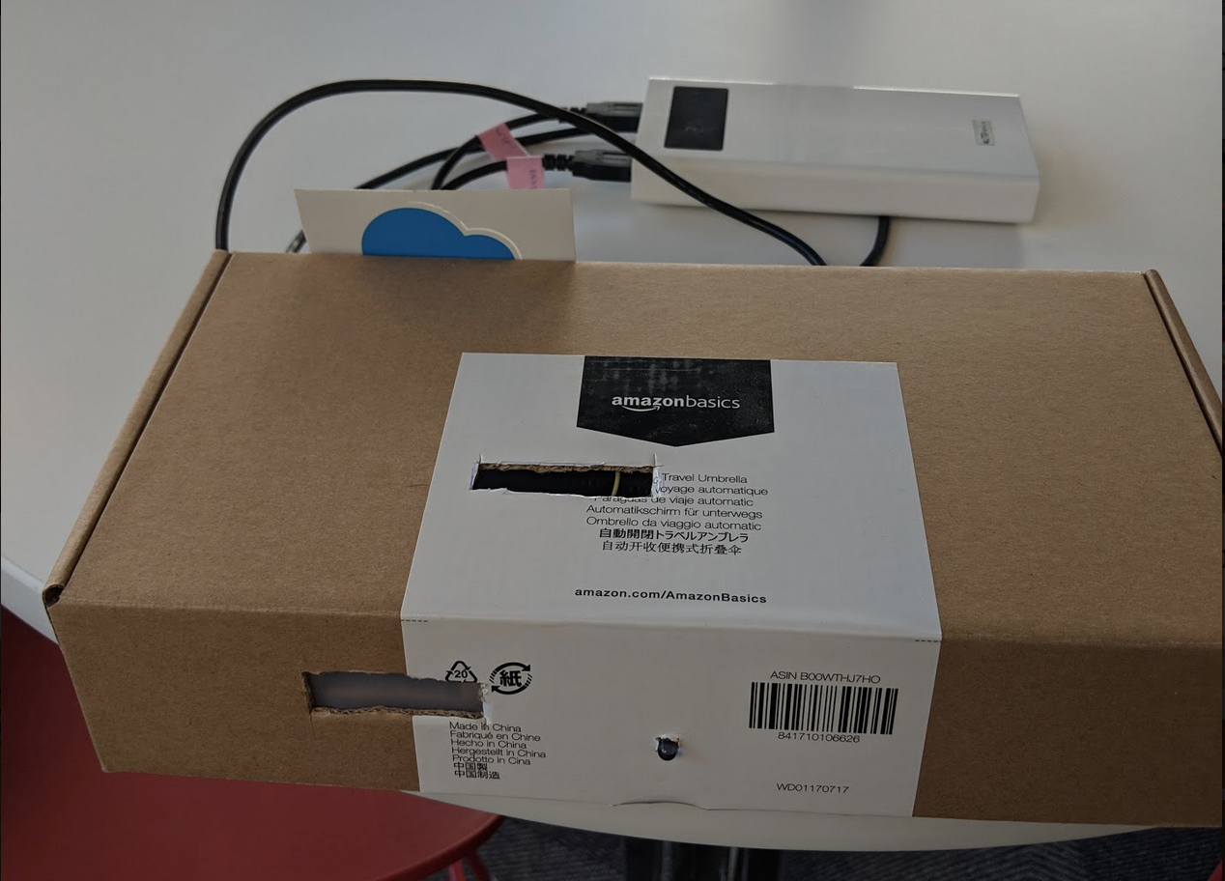

**Challenges**

There were several challenges I faced during this project.

**Wifi**

Wifi communication is difficult in an Arduino UNO board. Baud rate, WPA encryption, timeouts are some of the areas where problems can arise.

Talking to Adafruit feed is also a difficult task. Adafruit rate limits APIs to 1 request per second and therefore I had to take care that this limit is not exceeded. Even a call to the isConnected() function makes an API request. Therefore, a lot of consideration had to be given on network calls.

**XBee / Radio communication**

I had to understand XBee’s configuration to get the communication to working.

**Infrared**

To replicate IR signals for controlling the device, I had to scan the IR signal first. This took quite some time as there is a lot of IR noise in the background while scanning.

**Communication between 2 Arduino boards**

I couldn’t get the two Arduino’s to talk for several days and later realized that the 2 Arduino’s need to have their grounds connected.

**Memory usage on Arduino board**

I had to minimize my memory footprint at the byte level for my code to fit the Arduino board.

**Results**

The project end result was quite good as I was able to build a complete working product. I had met all goals that I had initially set. I even increased the scope of the project by incorporating IR instead of a physical relay switch. The product worked as expected and was well received at the IoT showcase.